CREATIVE EDUCATIONAL SERVICES KAMPALA

MID TERM ONE EXAMINATION 2024
PRIMARY SEVEN

INTEGRATED SCIENCE

Time allowed: 2 hours 15 minutes

CANDIDATE’S NAME:

INDEX NUMBER

SIGNATURE:

DO NOT OPEN THIS BOOKLET UNLESS YOU ARE TOLD TO DO SO
Read and follow these instructions carefully:
TOTAL

1. The paper has two sections: A and B.  2. Section A has 50 questions (50marks)  3. Section B has 5 questions (50 marks)  4. Answer ALL questions. All answers to both Sections A and  B must be written in the spaces provided.  5. All answers must be written using a blue or black ball point pen or ink.  6. Diagrams should be drawn in pencil.  7. Unnecessary crossing of work may lead to loss of marks.  8. Any handwriting that cannot be easily read may lead to loss of marks.  9. Do not fill anything in the boxes indicated; For Examiner’s  use only. | FOR EXAMINERS USE ONLY
 | QN. NUMBER | MARKS | EXAMINE  R’S  INITIAL
 | 1-10
 | 11-20
 | 21-30
 | 31-40
 | 41-50
 | 51
 | 52
 | 53
 | 54
 | 55
COMMENT TO THE CANDIDATE

(Questions 1 to 40 carry one mark each)
1. Name the largest group of mammals in Uganda.

2. Name one cold blooded vertebrate that has a body shell.

3. Suggest one way in which water is important in our bodies.

4. Which substance can exist in the three states of matter?

5. Which stage in the life cycle of a housefly is important to man?

6. Which part of the seed develops into a new plant?

7. Identify the part of a skeleton that protects the brain.

8. How does a gecko (lizard) help man in daily life?

9. Identify any one method of making magnets.

10. Where does fertilization take place in mammals?

11. Give one example of a bird with a chisel-shaped beak.

12. Why is a mushroom unable to make its own food?

13. Name the natural habitat of a rabbit.

14. Why do insects visit flowers?

15. Why are cockroaches considered to be vectors.

16. Why is distilled water not good for drinking?

17. Name the mineral salt found in iodized salt.
_
18. Of what importance is a blubber to a whale?

20. Why does a fish dies soon after it has been removed from water?

21. How can one control echoes in cinema halls?

22. Paul uses a wheelbarrow to carry potatoes from his garden to the market.
What is the advantage of using such a machine.

23. Name one product of petroleum.

24. How does the use of electricity to cook conserve the environment?

Use the diagrams below to answer question 25.
A 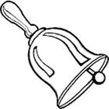 B C

25. Which bell will produce the highest pitch of sound?

26. What type of reproduction does a frog undergo?

27. Convert 300C to F.

28. Define a nursery bed.

29. What process will you use to recover salt which has dissolved in water?

31. Fish and birds have streamlined body shapes. Of what importance is this to the
animals?

32. Name the form of energy stored in a dry cell.

33. In what way can a child get natural immunity?

34. How useful are the ligaments in the human body?

35. Mention the importance of a micropyle to a bean seed.

Below is a blood cell. Use it to answer questions 36 and 37.

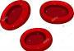
36. Name the blood cell shown above.

37. What is the function of the blood cell you have named in No. 36 above?

38. Mention one characteristic of arachnids.

39. Give one example of a drupe.

40. When do we use the displacement method?
_
_
SECTION B
41. Name the parts of the body where we find these joints;
(a) Ball and socket joint _

(b) Hinge joint

(c) Plane (Gliding) joint

(d) Pivot joint

42. (a) Define the term “Frequency” in relation to sound energy.
_

(b) Mention two factors that determine the pitch of sound of a guitar.
(i) _ (ii) (c) Write down one way of storing sound.

43. The diagram below shows a flowering plant. Study and use it to answer the questions that follow.
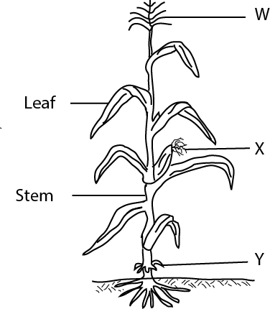
(a) To which group of flowering plants does the above plant belongs?

(b) What type of root system does the plant have?
_

(c) State the importance of root marked Y to the plant.
_
(d) In which one way is part W different from X in their reproductive function?

 |  | _
44. | (a) | Which type of soil is suitable for agriculture?
 | (b) | Give a reason to support your answer in (a) above.
 | (c) | Mention one way how soil is formed.
 | (d) | Which component of soil helps in improving soil aeration?
45. Match the following terms in A with their correct definitions in B
 | (a) | A B  Incubation - A type of chicken kept for egg production.
 | (b) (c) (d) (a) (b) (c) (d) | Brooding - Shortening of the upper part of the birds’ beak. Layers - Provision of favourable conditions to eggs to hatch. Debeaking - Care given to chicks from 1 day to 8 weeks.  Incubation Brooding Layers  Debeaking
46. | (a) | Explain the term “Family Planning”.  _
 | (b) | Give one artificial permanent method of family planning.
 | (c) | Suggest one reason why some parents have many children.
 | (d) | Write one advantage of practicing family planning.
47. | (a) | By what process does a fish get oxygen from water?
 | (b) (i) | State the function of the parts of a fish below on its body. Lateral line
 | (ii) | Nostril
 | (c) | How are the eggs of a fish fertilized?

48. The diagram below Q, R and S show the stages of germination of a seed. Study and use it to answer the questions that follow.

(a) Name the part marked X
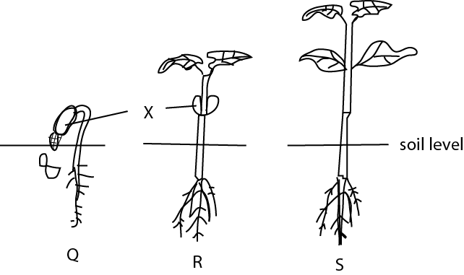

(b) How is the part marked X useful to the seedling at stage R.

(c) Why is the part marked X useless at stage S?

(d) What type of germination is shown by the seed.

49. (a) In which way is the sun useful to plant life?
_

(b) List down any two raw materials needed for photosynthesis to take place. (i)
(ii)
(c) Name the food manufactured by green plants during photosynthesis.
_

50. (a) What are poultry vices?

(b) How is litter from a deep litter system useful to a crop farmer?

(c) State any two disadvantages of free range system of poultry keeping.

(i)
(ii)
51. (a) What is a balanced diet?
_

(b) State the general word used to mean diseases caused by lack of a balanced diet.

(c) Give two reasons why people fail to have a balanced diet.
(i) _
(ii) _
52. (a) Suggest the blood component affected by;
(i) HIV (ii) Plasmodium (b) How are bones related to blood?

(c) What advice would you give to someone whose baby has anaemia?
_
53. The diagram below shows a fracture. Use it to answer question 53.

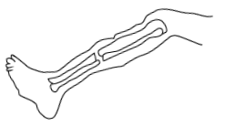
(a) What type of fracture is shown in the diagram above?

(b) State any two causes of fractures.

(c) Apart from the type of fracture stated above, mention any one other type of fracture.

54. (a) What is pollination?

(b) Name the gametes in plants which are similar to sperms in animals.

(c) Which part of a flower develops into a fruit?

(d) Give one example of a berry.

55. (a) Give an example of each of the following groups of birds.
(i) Birds of prey: (ii) Wading birds:
(b) Mention one advantage of birds to man.

(ii) Mention any one danger of birds to man
P.7 SCIENCE MID TERM I 2024

1. Primates
2. Turtle
3. It makes digestion possible/Water dilutes toxins to make them less harmful/Water helps in absorption of food/maintains body shape/blood movement
4. Water
5. Larva
6. Cranium/skull
7. …..
8. A gecko eats up harmful insects that fly in
the house and those that crawl on the walls.
9. Induction/stroking methods/Electrical method
10. In the oviduct/In the fallopian tubes.
11. The wood pecker
12. …..because it lacks chlorophyll.
13. Burrow
14. To get/collect nectar.
15. They spread germs that cause diseases.
16. …because distilled water lacks mineral
salts.
17. Iodine
18. It keeps the whale warm.
19. To have enough light in the room/to regulate heat in the room.
20. Due to lack of oxygen
21. By putting soft wood boards on the walls/By putting thick carpets on the floor.
22. He uses less effort.
23. Petrol/Kerosene/Vaseline/Diesel/Plastic/ Polythene bags.
24. It reduces the rate at which people cut down trees for wood fuel.
25. Bottle N.
26. Sexual reproduction.
28. Is a small garden where seeds are first planted before they are taken to the main garden as seedlings.
29. Evaporation.
30. To prevent the spreading of lung infections as a result of smoking.
31. Streamlined body shaped help fish and birds overcome the force of viscosity.
32. Chemical energy
33. Through breast feeding/After suffering and recovering from an illness.
34. Ligaments join bones to bones.
35. It admits moisture and air into the seed during germination.
36. Red blood cell.
37. It transports oxygen in the body.
38. They have two main body parts. They are wingless/They eight jointed legs.
39. Mango/coconut/Avocado
40. When finding the volume of objects with irregular shapes.
41. –
(a) Shoulder/Hip (pelvic girdle) (b) Knee/elbow
(c) Ankle/wrist
(d) neck
42. –
(a) Frequency is the number of vibrations
produced per second.
(b) The thickness of the wire/The tension/The length
(c) By recording/By writing
43. –
(a) Monocotyledonous plant
(b) Fibrous roots
(c) Provide extra support
(d) W produces pollen grains whereas X
receive pollen grains

⎛ 9 0C ⎟
⎞
x
⎜
⎝ 5 ⎠

+ 32 = 0F
44. –
(a) Loam soil
(b) …because loam soil has a balanced

27.
9 x 30
5
54 + 32

+ 32 = 0F

= 0F
amount of plant nutrients.
(c) Through weathering of rocks/Through decomposition of organic matter.
(d) Humus/organic matter

860 = 0F
45. –
(a) Provision of favourable conditions to eggs to hatch.

(b) Care given to chicks from 1 day to 8 weeks.
(c) A type of chicken kept for egg production.
(d) Shortening of the upper part of the
bird’s beak.
46. –
(a) The use of birth control methods to plant when to have and not have children in the family.
(b) Vasectomy/Tubal ligation
(c) Ignorance about family planning methods/Security during old age/High fertility rate/Cultural beliefs/prestige.
(d) It helps parents have a manageable number of children/It enables parents provide enough basic needs.
47. –
(a) By diffusion
(b) (i) To detect the movement of sound waves in water.
(ii) To smell/taste food.
(c) the male fish sheds sperms on them and they are fertilized externally.
(b) Red blood cells are made from the bone marrow.
(c) ….
53. –
(a) Simple fracture
(b) Rough games, vigorous exercises, accidents, poor walking postures
(c) Compound fracture/ green stick fracture, comminuted fracture
54. –
(a) Pollination is the transfer of pollen grains from the anthers to the stigma.
(b) Pollen grains
(c) Ovary
(d) Tomatoes/Oranges/Passion fruits
55. –
(a) (i) Eagle/hawk/kite/owl/kingfisher
(ii) heron/crested crane/flamingo/
marabou stork/Ibis
(b) (i) Some are eaten as food/Some eat crop pests/tourist attraction for income generation.
(ii) Some are crop pests/Some are
vectors/They pollute the environment.

48. –
a) Cotyledon
b) Provides food to the plant
c) The food in the cotyledon is used up d) Epigeal germination
49. –
(a) It aids photosynthesis. (b) Water/carbon dioxide (c) starch
50. –
(a) These are bad habits among poultry birds.
(b) Litter is used as manure in a crop garden.
(c) Birds can easily get lost/Birds can
easily be killed by predators/Eggs get lost easily.
51. –
(a) A meal that contains all food values in their required right amounts.
(b) Deficiency diseases.
(c) Due to drought/Floods/pests and diseases/poverty/ignorance.
52. –
(a) (i) White blood cells. (ii) Red blood cells.

